Feudalism
During the middle Ages, Kings were _________________ to maintain law and order. People needed protection for themselves, their homes, and their lands. This led to the development of ____________

Roles and Responsibilities
Monarch
Lord/Vassal
Knight
Peasant/ Serf

Feudalism: Describes a feudal society is where land is held in exchange for service, and obedience is rendered in exchange for protection. “Society is hierarchically ordered with a military class of highly-trained and
Expensively-equipped warriors supported by a mass of peasants who provide labor and are tied to the land”

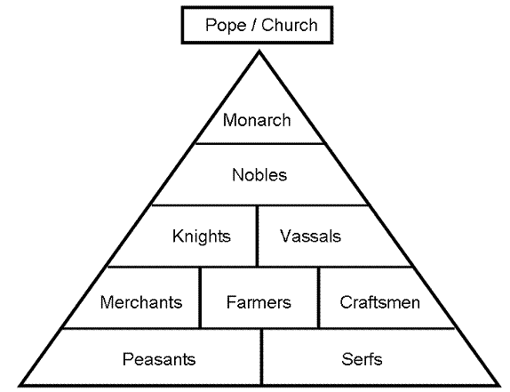
The lord was in broad terms a noble who held land, a vassal was a person who was granted possession of the land by the lord, and the land was known as a fief. In exchange for the use of the fief and the protection of the lord, the vassal would provide some sort of service to the lord. The peasants/serfs are the ones that perform the services and live in poverty.

• The exchange of land and Serfdom. The peasants/serfs stayed on the property and work the land for the vassal. The products created on the land would benefit the lord as far in local and international trade.
• Required protection/military service for the peasants who worked the land provided by the vassals.
• The lower class did not possess any political or economical power.

Historical Example | Who had the most Power? | Which class status did the majority of the population belong? | What were the major exchanges between the classes?
In Japan between the years 1185 to 1868, the shogun ruled the country through the daimyo (nobles), who were the heads of the samurai. The Lower class which was approximately 87% of the population formed the land in exchange for protection by the samurai.

In pre-colonial Pakistan, a jagir was a grant of land located in various districts.Military chiefs were permitted by the overlord to take in the products from the jagir only if they would keep order and a provide military protection for the commoners.

In Medieval Europe, Vassals (Knights or Lords) were given fiefs (a portion of land) by the king. The peasants 90% of the population worked the fiefs for the Vassals in exchange for protection, food, and Shelter.

Similarities:

Differences:

