The Power of the Church
Church Power at its Height
In the 1200s, the church reached the _____________ of its power. Two pope’s significantly _________________ the power of the church.
- Pope Innocent III established _______________________________.
  - He exercised his power over King _____________ of England when he ___________________ the King and placed his kingdom under interdict.
- ___________________________ claimed the right to overthrow kings and emperors.
  - Gregory tried to crown a new emperor when he got into a disagreement with the king of the Holy Roman Emperor.
As the church _____________________ its power, it came into direct _______________ with the kings
and Emperors of Europe.

The Holy Roman Empire
The first power struggle unfolded in the ___________________________________ between the emperors and pope.
- _____________________ was a great ruler of Medieval Germany. He formed a close alliance with the church to increase his power. In 962, the pope rewarded Otto by crowning him _________________ of the Holy Roman Empire.
The Holy Roman Emperors wanted the power to decide who would become bishops and abbots within their kingdoms. This was called __________ _____________________.
- Under this practice, emperors “______________________” or presented a ___________ with the ring and a staff that symbolized their office.

Emperor vs. Pope
Pope _____________________________ banned lay investiture in 1075. This prevented any German Emperors from appointing church officials. This angered the German Emperor, _______________________, and he ordered that the pope step down from the papacy.
- Pope Gregory did not listen and instead ordered that Gregory be ______________________. Henry had no choice and had to _______ for the pope’s forgiveness.
- Henry IV waited in the snow for ______ full days before Pope Gregory finally ended his excommunication. The pope had humiliated the king.
- In 1122, the Church and King reached a ____________________ known as the _____________________________________. It stated that only the _____________ could appoint a bishop, but the king could _____________ the appointment.

Trouble in Constantinople
In the 1050s, the Muslim ________________________ invaded the Byzantine Empire. By 1071, the Seljuks had overran most of Byzantine lands and had taken control of the ___________________________.
- Holy Land = Jerusalem and other places in Palestine that Christians believed Jesus lived and preached.
Because the Seljuk Turks controlled the Holy Lands, Christians could not take a _______________________ to the Holy Land. I smell trouble!!
- The Byzantine Emperor ___________________ sent an urgent message to Pope ______________ II. He requested that Christian _____________ be sent to help him fight the Turks. The pope agreed.

Council of Clermont
At the _______________________________ (1095), Pope Urban asked bishops and nobles to take action.
“From Jerusalem and the city of Constantinople comes a grievous (troubling) report. An accursed race…has violently invaded the lands of those Christians and has depopulated (killed) them by pillage and fire.”
- Urban then asked for a _________________ to free the Holy Land:
“Both knights and footmen, both rich and poor…must strive to help expel the Seljuks from our Christian lands before it is too late…Christ commands it. Remission (forgiveness) of sins will be granted to those going thither (there).”
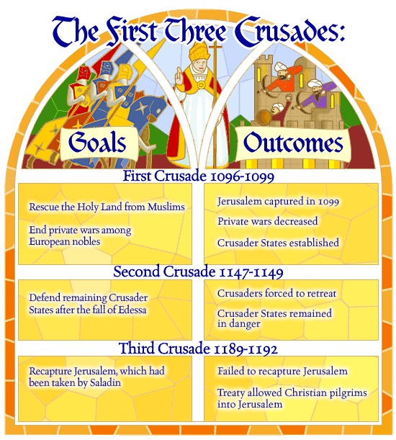
- Beginning in 1096, ___________________ of knights were on their way to the Holy Land to fight.

Reasons for the Crusades
People joined the crusades for religious, political, and economic reasons
- ___________________________ – many ordinary people were inspired by their faith and wanted to take back the Holy Land.
- Economic Factors – many knights hoped to win _____________ and land from the crusades, or to escape ________ at home.
- Political Reasons – Pope Urban hoped it would increase his __________ in Europe and maybe mend the ______________ (split in the Christian Church) being fought by knights.

Effects of the Crusades
The crusades were a great example of the forceful nature of the ___________ during the Middle ages. It also had lasting effects on the World.
- Merchants were able to expand their ____________ routes into Asia.
- The failure of the crusades __________________ the power of the pope and _______________ the power of the Kings.
- For ___________________, the intolerance and prejudice displayed during the Crusades left behind a legacy of bitterness and ______________. This legacy continues today.
  - In addition, relationships between Muslims, Jews, and Christians _____________________ as a result of the Crusades.

