The Byzantine Empire
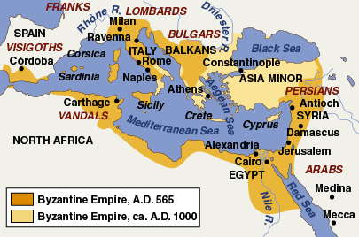
Constantine and Constantinople
_________________ invaders pummeled the Western Roman Empire, and the Roman Emperor ______________________ and his successors shifted the capital of Rome to ________________________.
- Constantinople was located on the ________________________. This provided an excellent ________________ and guarded the city on 3 sides by water.
- Constantinople was the perfect location for the Byzantine Empire because it was easy to ______________and it was at the _________________________________________________________________________________.
For centuries, the city’s location made it Europe’s ______________________ marketplace!

The Reign of Justinian I
The Byzantine Empire reached its peak under the emperor ___________________ who ruled from 527 to 565.
Justinian was a very good Emperor with many accomplishments:
- He recovered ______________________ that had been lost to invaders in North Africa, Italy, and Spain.
- He _________________________________ after it was destroyed by Fire. The most beautiful building was the church called the ______________________________, meaning “Holy Wisdom.”
- He reformed the law and called it __________________________________. This was one of the largest bodies of civil laws!
Later, European kings and queens would base their laws on Justinian’s Code and it is still used in __________________________________today!
- Justinian used his Code to ____________________ under his control. He ruled as an ____________________, or sole ruler with _______________________________________.
The Byzantine Emperor not only had power over the empire, but also _________________________________. He was considered Christ’s co-ruler on earth.
- “The Emperor is equal to men in the nature of his body, but in the authority of his rank he is similar to God, who rules all.”
The Byzantine Empire flourished under a ____________________________________________ – trade and industry flourished!
- They also had one of the ________________________________________________ in the world – Greek fire was their most feared weapon!

Byzantine Christianity
Since early Christian times, ________________________________________ over church leadership. Although the Byzantine Emperor was not a priest, he controlled church affairs and appointed the __________, or highest church official.
- During the middle ages, a dispute over the use of ____________, or holy images, led to a split in Christianity.
- In the 700s, a Byzantine Emperor _____________________________________ and this led to violent battles
As a result of this controversy, in 1054 the eastern and western Christian church ________________________
_____________________________________ – this became known as the ___________________________.
- Byzantine/Eastern = ___________________________________________
- Western = ___________________________________________
Fall of the Byzantine Empire
By the time of the Great Schism, the Byzantine Empire was in decline. Struggles over ___________________ ___________________, court intrigues, and _____________________________ weakened the empire.
- Beginning in the 1090s, the Byzantine Empire fought the _______________________________ during the __________________________ (________________________ between Christians and Muslims).
  - In 1204, __________________________________was plundered…
  - In 1453, Ottoman forces took the city of Constantinople under their ruler _______________________. They renamed the city ______________________ and it became the capital of the _________________ Empire.

