NB # ______
The Hellenistic Age
Greek Achievements
Despite political trouble and wars, Greek thinkers, writers, and artists made many important achievements.
Philosophy and Government
- In Athens, philosophers used rhetoric, or skillful speaking, to advance their careers. The 3 famous Greek philosophers were:
  - _______________________ ~ developed the Socratic method to find truth and self-knowledge.
  - Plato ~ described an ___________________________________ in The Republic and advocated the rule of a philosopher-king.
  - ____________________________ ~ tried to find the best form of government and promoted the idea of a “golden mean” – a government that is not too extreme.
- One of the greatest Greek rulers was ________________________, who helped poor Athenians participate in government by paying citizens for their government work.
Art and Architecture
- The Greeks also made advances in art and architecture – promoting _____________________________.
- The greatest piece of Greek architecture was the _________________, a temple for the Goddess Athena.
Literature and Drama
Greek writers composed ________________ and _________________. Actors played the roles wearing masks.
- Tragedies ~ plays that told stories of ___________________________________ and ended in disaster.
  - Greatest playwrights were Aeschylus, Sophocles, and Euripides.
- ____________________________ ~ Plays that were humorous and made fun of people and customs.
  - The most famous comedian was Aristophanes.
History
- Greek historian, Herodotus, was called the “_________________________________________”

Philip II Unites Greece
The conflicts among the Greek city-states made them ____________ and _____________________ to invaders.
- In 338 B.C., Athens fell to the Macedonian army led by _____________________________ – this marked the end of Ancient Greece.
- King Philip _____________________________________________________ under his rule for the first time in history!
- King Philip dreamed of conquering the Persian Empire, however, he was ________________________ before he could pursue his dream.
His son, ______________________________, became King at ________ years old. He would pursue and achieve his father’s dream.
- Alexander was very smart and was tutored by Aristotle in Greek literature, math, and science.
- He was also one of the greatest ___________________________________!!

Alexander the Great
Before becoming King, Alexander was one of the best soldiers in the Macedonian military.
- As King, he began to organize the forces needed to conquer Persia. To do so, he developed the phalanx.
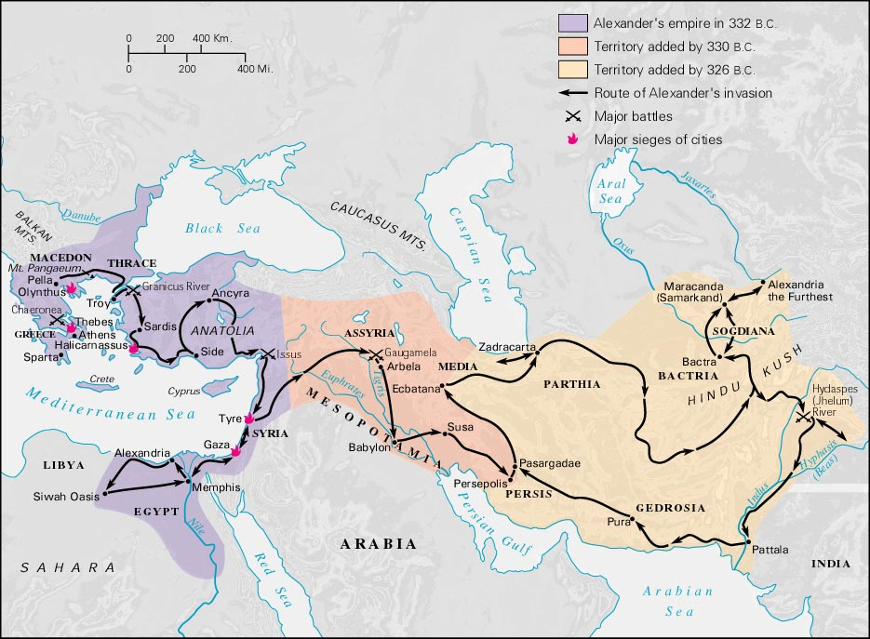
  - ______________~ a military strategy where soldiers carried overlapping shields and long spears.
Alexander the Great successfully _________________________________ under Darius III. This was a HUGE accomplishment because the Persian Empire stretched from Egypt to India.
- Afterwards, Alexander moved into ____________. However, his troops were too tired to continue and they turned back.
On the way back to Greece, Alexander came down with a fever and _______ at the age of ____________.

The Hellenistic Age
Although Alexander’s empire soon crumbled after his death, his legacy continued for hundreds of years – known as the __________________________.
- His most significant achievement was the _________________________________________ across the Mediterranean and East.
- Alexander founded many ___________across the empire. The local people, _____________________, or absorbed, Greek culture and ideas.
- In addition, Alexander established the city of _________________________ (in Egypt) which would become a cultural capital with laboratories, libraries, lecture halls, and a zoo.
- Alexander’s empire also gave __________________________________ – they were able to leave home and learn to read and write!!

Advances of the Hellenistic Age
The cities of the Hellenistic world made great advances in the arts and sciences.
________________________________
- Zeno founded a new philosophy called _______________________________, which urged people to avoid desires and disappointments of life.
Math and Science
- Pythagorean Theorem (a2 + b2 = c2): (Pythagoras) formula to calculate the sides of a ______________.
- ______________________________: (Aristarchus) theory that the sun was the center of the universe and the earth revolved around the sun.
- Hippocratic Oath: (_______________________________) set of ethical standards for doctors.
Drama
- This was also the Golden Age of Greek drama.

