The Fall of the Roman Empire
Quick Recap!
In 509 B.C., the Romans drove out the _________________ from the Italian Peninsula and established the ____________________________________.
- Under the Roman Republic, an ____________________________ was established by the ___________ (rich people) and eventually the ______________________ (middle class people) gained more power.
However, after the ___________________________ many people became homeless and this led to Civil Wars.
- ______________________ arose from the Civil Wars and forced the Senate to make him ___________ of Rome, but this did not last long because he was ____________________________________.
The Roman Empire was established under Augustus and this began a period called the Pax Romana.
- _____________________________________________________________________________...

Political and Economic Problems
After the death of Emperor _______________________________ in 180 AD, the golden age of the _________ ____________________. For the next 100 years, political and economic turmoil plagued the Roman Empire.
- During this time, Emperor after Emperor is overthrown by __________________, or military generals who ______________________________ with their troops.
  - These tyrants usually only ruled for a few months.
  - In one 50 year period, at least _____Emperors reigned. Only _____ died of natural causes…
  - ___________________________________________________________________________!!!
At the same time, the empire was shaken by terrible social and economic troubles including ______________, ___________________________, and _____________________________________.

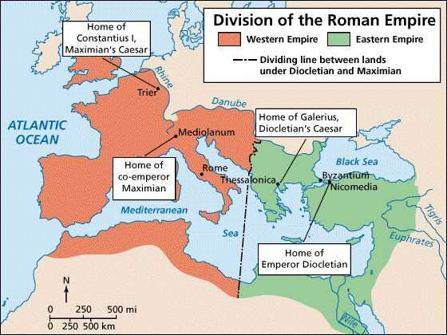
The Empire Divides
In 284 AD, Emperor _____________________set out to restore order.
- To better handle the challenges facing the huge empire, he __________ it into 2 parts the _________________________ and the ___________________________________________.
- Diocletian ruled the wealthier Eastern Roman Empire and appointed a _____________________, Maximian, to rule the Western Roman Empire.
Diocletian also took steps to improve the empire’s _____________ by fixing the prices of goods to ________________ inflation (___________________)…but it was too late.

Constantine’s Reforms
In 312 AD, talented general ____________________________ gained the throne. As emperor, Constantine ______________________Diocletian’s reforms.

Constantine change European History in 2 important ways:
- ___________________________________________________________________________. This allowed freedom of religion to all citizens.
- He established a _______________________________________________. Constantinople was called the “_______________________” and was located in the Eastern Roman Empire. It would become the new center of Roman power!!!

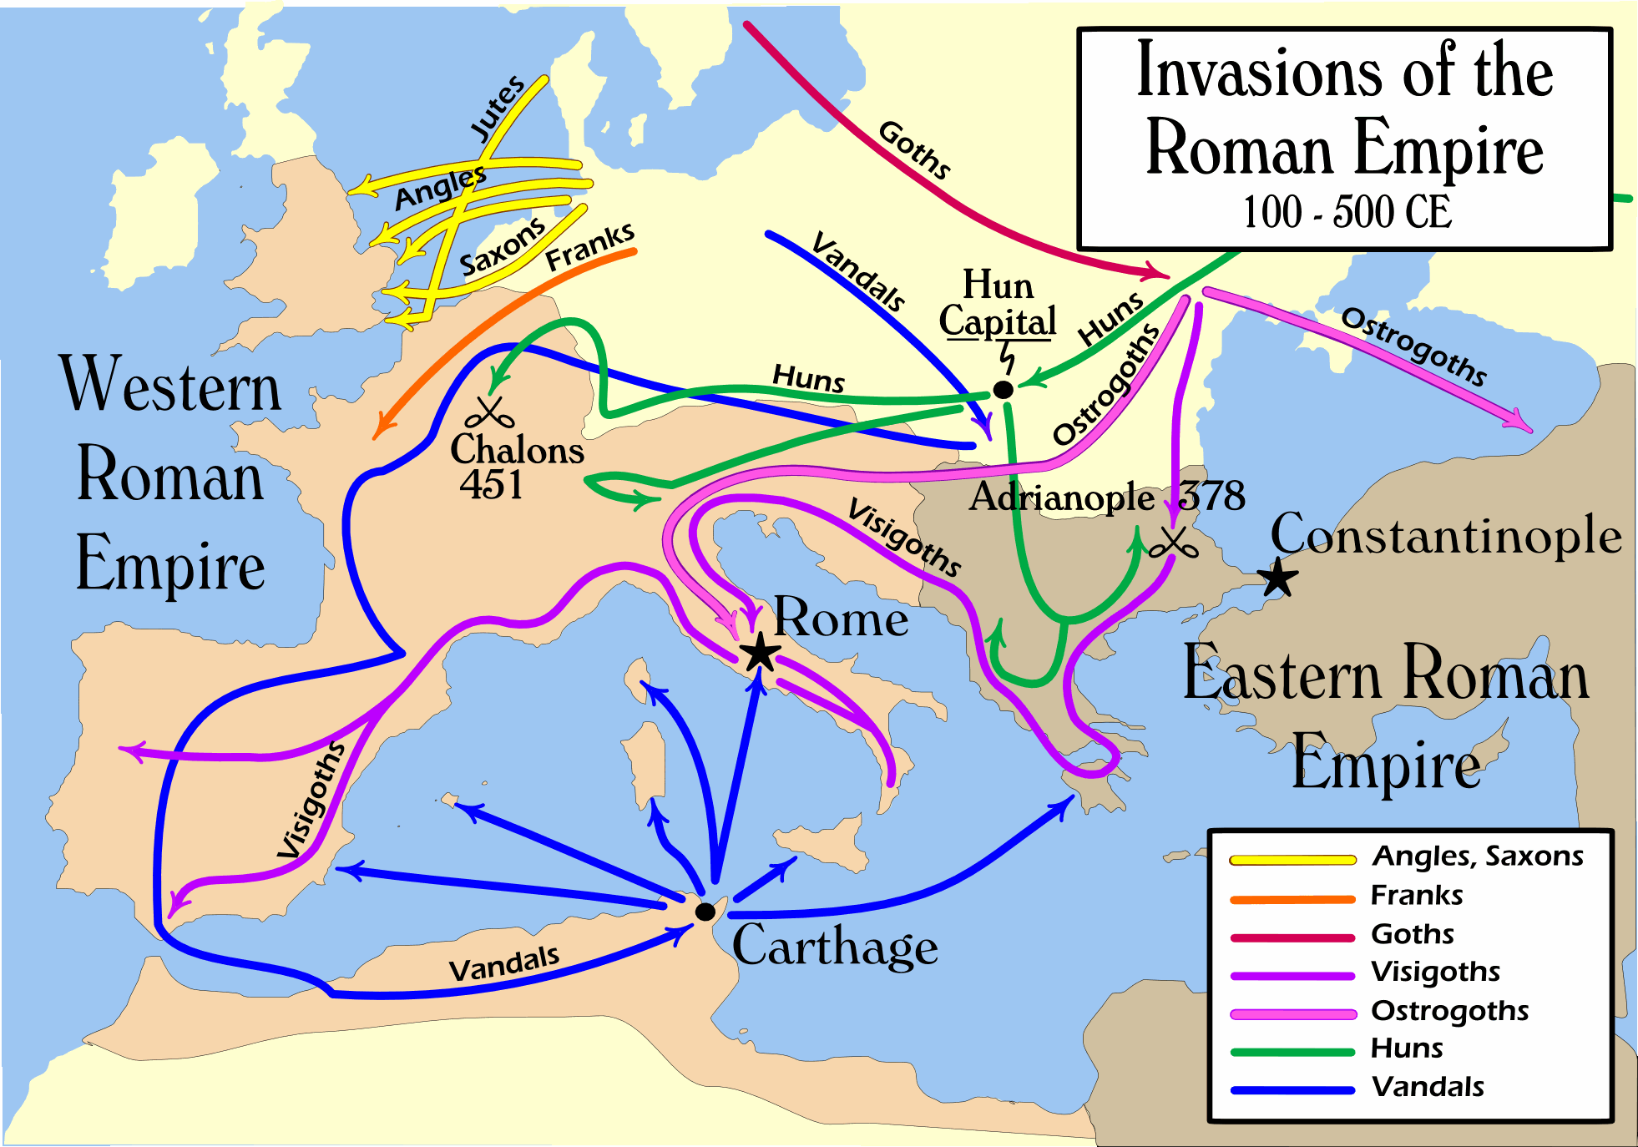
Invaders!
For centuries, Rome had faced attacks from the _______________________ who lived North. However, around 200 AD a chain of invaders would overwhelm Rome.
- Wars in East Asia sent a nomadic people, called the ___________, migrating towards Europe. The Huns reached Europe in 370 AD and fought the Germanic tribes.
- The ___________________, __________________, ___________, _______________, ______________, _____________, and _________ all began to invade the Roman Empire.
The Roman legions were unable to protect Rome.

Rome is Sacked!
In 378 AD, the Roman army suffered a stunning defeat when it was trying to keep the Visigoths out of Adrianople.
- This illustrated that ___________________________________________________!
- In 410 AD, the Visigoth General Alaric overran Italy and plundered the city of Rome.
Meanwhile, the Vandals moved through Gaul and Spain into North Africa. Gradually, the Germanic tribes began to __________________________________________________________.
- In 434 AD, ____________________________ (aka “The Scourge of God”, invaded Europe sending more Germanic tribes into the Roman Empire.
- Finally, in 476 Odacer, a Germanic leader, overthrew the Roman Emperor – ______________________ _________________________________________

Too Many Problems
The fall of the Roman empire was a ____________________________________________ in World History!!!

So why did Rome fall?
- _________________________________ - Rome could not protect itself from __________ because the legions were too weak and Rome hired _______________________ (foreign soldiers) to defend its borders.

- ___________________________________ - Government was more oppressive and authoritarian and lost support of people. Corrupt politicians undermined the loyalty to Rome. ______________________ also weakened Rome.

- ____________________________________ - Heavy _________, reliance on ___________________, lack of new technology, and poverty led to a failing economy.

- Social Decay - _________________________________, discipline and devotion to the Roman Empire led to the collapse. Providing “bread and circuses” may have also undermined self-reliance.

Did Rome Fall?
- The Roman Empire did _______ disappear off the map in 476 AD.
- The Eastern Roman Empire continued to exist for another 1000 years under a new name called the ________________________________________.

