Station #1 Roman Contributions to Literature
In the field of literature, the Romans owed a great debt to the Greeks. Many Romans spoke Greek an imitated Greek writing and poetry. Still, the greatest Roman writers used Latin to create their own literature. In his epic poem the Aeneid, Virgil, tried to show that Rome’s past was as heroic as that of Greece. He wrote his epic poem similar to Homer’s Odyssey, telling the story of Aeneas a soldier who escapes from Troy to found Rome. Virgil wrote the Aeneid soon after Augustus came to power. He hoped it would increase patriotism and help unite Rome after years of civil wars.
Below is an excerpt from the Aeneid. In it, Aeneas’s mother, the goddess Venus, brings gifts from the gods to her son. On these items are engravings of Latium’s past and its future.
And he, his eyes glistening, looked at the god’s gift and was overjoyed. He feasted his sight on each piece in turn, turning it this and that way in his hands and feeling it lovingly—the huge brazen [bold] breastplate, the well-polished greaves [leg guards] of gold and silver, the flaming helmet with proud plumes waving from its crest, the keen [sharp] steel sword and, last of all, the immense shield with all the history of Italy embossed [imprinted] upon its blazing face. Not only stories of the past were there engraved, but the god, with prophetic vision, had caused his workmen to hammer out scenes far in the future. There were shown the twin boys, Romulus and Remus… the high walls and towers of Rome yet unborn… Romulus waging war… the descendants of Aeneas fighting valiantly [bravely] for freedom, the silver geese waddling through the streets cackling a warning that the Gauls were at the gates, and the barbarians themselves, crouching in the dark thickets [grasses], ready to storm the walls.
Questions to Answer:
- What was the story of the Aeneid? For what purpose did Virgil write the Aeneid?

- What things are described in the Aeneid that should make Romans feel proud? List at least three.

- What things about your own country make you feel proud? List at least three.

Station #2 Historians Tell the Story of Rome

Roman historians pursued their own theme – the rise and fall of Roman power. Like the poet, Virgil, the historian Livy tried to increase Roman patriotism and restore traditional Roman values by telling stories of Rome’s past. In his history of Rome, Livy recounted tales of great heroes such as Horatius and Cincinnatus.
Another historian, Tacitus, wrote bitterly about Augustus and his successors, who, he felt, had destroyed Roman liberties. He admired the simple culture of the Germans who lived on Rome’s northern frontier and would later invade the empire.

Read the passage below from “The History of Rome” written by Livy:

“…In history you have a record of the infinite variety of human experience plainly set out for all to see; and in that record you can find for yourself and your country both examples and warnings, fine things to take as models, base things, rotten through and through to avoid.”

Questions to Answer:

- Who were two famous Roman historians?

- How did Roman historians promote patriotism?

- Using the passage from “The History of Rome,” in what ways does Livy say we can learn from history?

Station #3: Roman Entertainment
Throughout the Roman Empire, rich and poor alike loved spectacular forms of entertainment. At the Circus Maximus, Rome’s largest race course, chariots thundered around an oval course, making dangerously tight turns at either end. Fans bet feverishly for their favorite teams – the Reds, the Greens, the Blues, and the Whites - and successful charioteers were hailed as heroes.
Gladiator contests were even more popular. Many gladiators were slaves who had been trained to fight. In the arena, they battled one another, either singly or in groups. Crowds cheered a skilled gladiator and a good fighter might even win his freedom. But if a gladiator made a poor showing sometimes the crowd turned their thumbs down, a signal that he should be killed.
During the Pax Romana, the general prosperity hid underlying social and economic problems. To the emperors who paid for them with taxes they collected from the empire, these amusements were a way to pacify the city’s restless mobs. In much the same spirit, the government provided free grain to feed the poor. Critics warned against this policy of “bread and circuses,” but few listened.

Questions to Answer:
- What is the circus Maximus? What type of races occurred at the Circus Maximus?
- Who were the gladiators? What did they win if they were a good fighter? What would happen if the gladiator did not fight well?
- How did the Gladiatorial games hid social and economic problems during the Pax Romana?

Station #4: Roman Art and Architecture
Roman art and architecture was based on Greek and Etruscan models. However, the Romans made adaptations to develop their own unique style of Art.
Like the Greeks, the Romans stressed realism, portraying their subjects with every wart and vein in place. The Romans also broke new ground by focusing on revealing an individual’s character. A statue of a soldier, a writer, or an emperor might capture an expression of smugness, or pride.
Some Roman sculpture, however, was idealistic. For example, sculptors transformed Augustus, who was neither good looking nor imposing into a symbol of power and leadership.
Romans used works of art to beautify their homes. Examples of these works were preserved in Pompeii, a city buried by volcanic eruption in 79 AD. Artists depicted scenes from Roman literature and daily life in splendid frescoes (water color paintings) and mosaics. A mosaic is a picture made from chips of colored stones or glass.
The Romans also made advances to architecture. They made their architecture grand. Immense palaces, temples, and stadiums stood as mighty displays of Roman power and dignity.
The Romans also improved on existing structural devices such as columns and arches. Using concrete as a building material, they developed the rounded dome as a roof for large spaces. The most famous domed structure is the Pantheon, a temple that honors the many Roman gods. It still stands in Rome today.
Questions to Answer:
- How did Roman art and architecture differ from Greek art and architecture?

- What improvements were made to columns and arches?

- Examine the pictures attached. What types of Roman art and architecture do you see in the pictures?

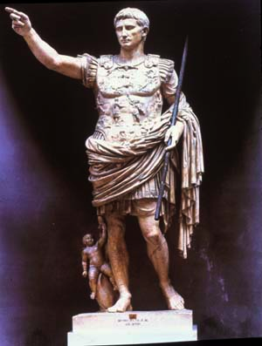
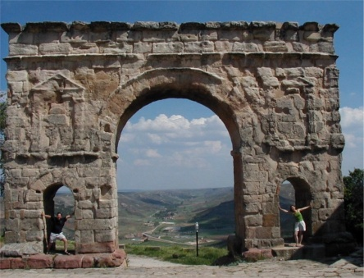

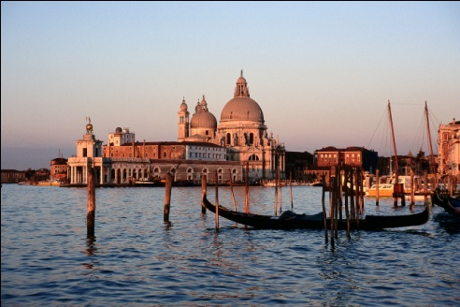

Station #5: Roman Engineering and Science
The Romans were excellent engineers. Engineering is the application of science and mathematics to develop useful structures and machines. Roman engineers built roads, bridges, and harbors throughout the empire. Roman roads were so solidly built that many of them were still used long after the fall of the Roman Empire. Roman engineers also built many large aqueducts, or bridge-like stone structures that carried water from the hills into Roman cities. The wealthy had water piped in, and almost every city had public baths. Here people gathered not only to wash themselves, but also to hear the latest news and exchange gossip.
The Romans generally left scientific research to the Greeks, who were by that time citizens of the empire. Although Romans did little scientific research, they did put science into practical use. They applied geography to make maps and medical knowledge to help doctors improve public health. They also collected knowledge into encyclopedias. Galen, a Greek doctor, advanced the frontiers of medical science by insisting on experiments to prove a conclusion. Galen compiled a medical encyclopedia summarizing what was known in the field at that time. Likewise, Pliny the Elder, a Roman scientist, compiled volumes on geography, zoology, botany, and other topics, all based on other people’s work.
Questions to Answer:
- What were some of the advances made by the Ancient Roman engineers?

- How did these advances improve life in Rome?

- Who in the Roman Empire engaged in Scientific research? Who put science to practical use?

Station #7: Roman Laws
Probably the greatest legacy of Rome was its commitment to the rule of law and justice. During the Roman Empire, the rule of law created unity and stability. Many centuries later, the principles of Roman law would be the basis for legal systems throughout the world, including the United States!
During the republic, Rome developed a system of law, known as the civil law that applied to all citizens. These laws were known as the Twelve Tables. As Rome expanded however, it ruled many foreigners who were not covered under these laws. Gradually, a second system of law, known as the law of nations, emerged. It applied to all people under the Roman rule, both citizens and non-citizens. Later, when Rome extended citizenship across the empire, the two systems merged.
As Roman law developed certain basic principles evolved. Many of these principles are familiar to Americans today. An accused person was presumed “innocent until proven guilty.” The accused was allowed to face the accuser and offer a defense against the charge. Guilt had to be established “clearer than daylight,” using solid evidence. Judges were allowed to interpret the laws and were expected to make fair decisions. Penalties, however, varied according to social class, and lower-class defendants could be punished more harshly.

Questions to Answer:
- What were the basic principles of Roman law?

- How did Roman laws evolve between the Roman Republic and Roman Empire?

- Give two examples of how Roman principles of law affect life in the United States today.

Station #6: The Twelve Tables
Roman plebeians (the middle and lower classes of Roman society) made a big break through when the Twelve Tables were written down in 450 B.C. The 12 tablets were set up in the Forum, or Roman Marketplace. Plebeians had protested that citizens could not know what the laws were because they were not written down. The laws of the Twelve Tables made it possible for the first time for plebeians to appeal a judgment handed down by a patrician judge.

Read the excerpt from the “Law of the Twelve Tables” below:
Table VIII.
2. If one has maimed a limb and does not compromise with the injured person, let there be retaliation. If one has broken a bone of a freeman with his hand or with a cudgel, let him pay a penalty of three hundred coins. If he has broken the bone of a slave, let him have one hundred and fifty coins. If one is guilty of insult, the penalty shall be twenty-five coins.
3. If one is slain while committing theft by night, he is rightly slain.
4. If a patron shall have devised any deceit against his client, let him be accursed.
10. Any person who destroys by burning any building or heap of corn deposited alongside a house shall be bound, scourged, and put to death by burning at the stake provided that he has committed the said misdeed with malice aforethought; but if he shall have committed it by accident, that is, by negligence, it is ordained that he repair the damage or, if he be too poor to be competent for such punishment, he shall receive a lighter punishment.
23. A person who had been found guilty of giving false witness shall be hurled down from the Tarpeian Rock.
26. No person shall hold meetings by night in the city.
Table X.
1. None is to bury or burn a corpse in the city.
3. The women shall not tear their faces nor wail on account of the funeral.
Table XI.
1. Marriages should not take place between plebeians and patricians.

Questions to Answer:
- In what way the Laws of Twelve Tables help the Plebeians?
- After reading the Laws of Twelve Tables above, What laws surprised you? If so, which law and why?

#8 Roman Government
The Roman government changed significantly between the Roman Republic and the Roman Empire. Examine the chart below and answer the following questions:
 | Roman Republic | Roman Empire
Highest Officials | Two Consuls  - Elected each year  - Held Equal power  Dictator  - Appointed in times of emergency  - Held office for 6 months. | Emperor  - Inherited power  - Served for Life  - Worshipped as a god after death.
Governing Bodies | Senate  - Issued Decrees  - Held Enormous power  - 300 members  Popular Assemblies  - Citizens of Rome  - Two assemblies, military and tribal  - Elected magistrates, made laws, and made key decisions | Senate  - Issued decrees, acted as a high court  - Held little power as compared to the Emperor  - 600 members

Questions to Answer:
- Why do you think the senate held less power in the empire than in the republic?

- How do you think the founders of the Roman Republic would have viewed the government of the Roman Empire?

#9 Roman Religion
Rome began as a polytheistic society. They worshipped many gods that they adapted from the Greek gods and goddesses. However, when Christianitiy spread it spread into the city of Rome.
Rome was generally tolerant of various religious beliefs. However, the Romans were not tolerant to Christians. Roman officials found the Christians disloyal to Rome because they refused to honor the emperor with sacrifices or ask the traditional gods to protect the Roman state. When Christians met in secret to avoid persecution, rumors spread that they were engaged in evil practices. In times of trouble, this persecution of Christians would increase. Nero used Christians as scapegoats , blaming them for social and economic problems in the city. Over the centuries, hundreds of Christians were killed and became known as martyrs, or people that die for their beliefs.
Despite the attacks, Chrisitianity spread thoughout the Roman world. Jeus had welcomed all people, especially the lowly, the poor, and the oppressed. These people found comfort in his message of love, as well as his teachings of equality, dignity and the promise of a better life beyond the grave.
The persecution of Christians finally ended in 313 AD, when the emperor Constantine issued the Edict of Milan. It granted freedom of worship to all citizens of the Roman Empire. By the end of the century, the Emperor Theodosius had made Christianity the official religion of the Roman Empire and represed the practices of other faiths.
Questions to Answer:
- Why were Christians persecuted in Ancient Rome?
- How did Christianity spread through the Roman Empire?
- Which Roman Emperor stopped the persecution of Christians and how did he do this?

