NB # ______
Road to the American Revolution
Britain’s American Colonies
- Throughout the 1600s and 1700s, the thirteen English colonies along the eastern coast ______________.
  - ________________________________________ by leaps and bounds
    - 250,000 in 1700 to 2, 150, 000 in 1770
  - Economy prospered
    - Traded with Europe – remember ___________________________________??
- New sense of an “_________________________” identity
  - Colonists had been living in America for 150 years
  - Each colony had its _________________________________ and a large degree of independence
  - Colonists saw themselves as _____ British and ________ as Virginians or North Carolinians.
- Many actions taken by the British began to ______________ the colonists and tensions grew…

Navigation Acts (1651)
- Navigation Acts (1651) – colonies of Great Britain could _________________ with the mother country.
  - Designed to keep trade in England and support _________________________.
    - Mercantilism = __________________________________________________________ _______________________________________________________________________
  - Britain bought American _______________________ (ex. cotton) for low prices and sold ______________________________ (ex. cloth) back to the colonists at a higher price.
  - All colonial ships had to stop in an English harbor before going on to another country
- Led to period of Salutary Neglect
  - Britain did not pay too close attention to its colonies
  - Colonists enjoyed free period of ______________________________________

French and Indian War (1754)
- French and Indian War (1754 – 1763) ~ fought between the _______________ and the ____________ over lands in North America.
  - French (and Native American tribes) vs. Great Britain
  - British win!
  - __________________________________ (1763) = ended the war and made England the dominant power in North America. France had to give up most of its land in North America

Proclamation of 1763
- Victory in the French and Indian War led ________________________ between Britain and its colonist.
- Under the Treaty of Paris Britain claimed land east of the Mississippi River
  - Proclamation of 1763 ~ prohibited colonists from _____________________ of the Appalachian Mountains(to ease tensions with Native Americans)
  - Angered colonists and increased their independent spirit!

More Trouble..._________________!
- In order to fight the French and Indian War, Great Britain had run up a huge ______________.
  - To pay for the war, Great Britain started _______________________the colonists.
  - Ended Period of _____________________________________
- British Parliament began passing tax laws
  - Stamp Act, Quartering Act, Townshend Acts, Tea Act, Intolerable Acts
- Colonists were outraged and began to protest.
  - “___________________________________________________________”

Cartoon Analysis

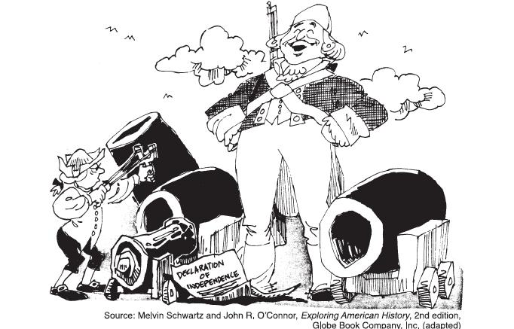

Cartoon Analysis Questions
- What do you see? (Students should simply point out all symbols, characters, objects, text, etc. that they notice. Try to keep them from jumping to interpretation until all pieces of the cartoon are pointed out.)

- What do you think? What message is the artist trying to convey? What do the symbols represent?

- What techniques has the artist used and why? (exaggeration, caricatures, humor, sarcasm, etc.)

- If you were an American Patriot (someone who wanted to break away from Great Britain) would you agree with the cartoonist? Why?

- If you were a Loyalist (a person who is still loyal to Great Britain), would you agree with the cartoonist? Why?

