Introduction to History
What is History?
Everything which happened in the _______________ (including yesterday) is _____________________.
History can either be written or oral:
- ________________________ = history which has been written down and preserved throughout time.
- Oral History = history which has been passed on by word of mouth such as through _______and songs.
Why Study History?
- To understand the importance of _________________________, most of which have roots in the past.
- Understanding the past, can help us understand what happens _______________ and what may happen in the _______________.
- “The past causes the present, and the present causes the future.”
Historians
Historians are like ______________________ who use clues to discover what occurred in the past.
- ____________, record, _____________about, and ________________ human experiences of the past.
- Evaluate evidence to determine if it is reliable.
Anthropologists
Anthropologists study _____________________________________ (both past and present).
- _____________________ = the way of life of a society which is handed down from one generation to the next through learning and experience.
- Culture includes the ______________________, values, and practices of a people.
Archaeologists
Archaeologists study past people and cultures through finding and analyzing material remains of human cultures.
Dig through dirt at sites in search of clues.
- “______________________” = anything ____________________________________ such as tools, coins, buildings, weapons, pottery, clothes, and artwork.
- “______________________” = the ______________________________________ (plants, animals, people), not things that were made. Examples: bones, skulls
Historical Tools
Historians (like detectives) use all sorts of tools to put together a historical story.
- ____________________
- Artifacts
- ______________________
- ______________________
- Written History
Written History Sources

____________________________________
- ____________________ or eyewitness accounts of an event
- experienced the event
- subject to different interpretations
Secondary Sources
- ______________________ records of what happened
- They did _______experience the event

Primary or Secondary Historical Source?
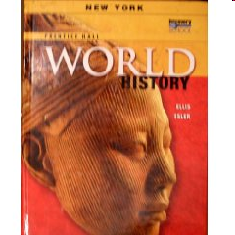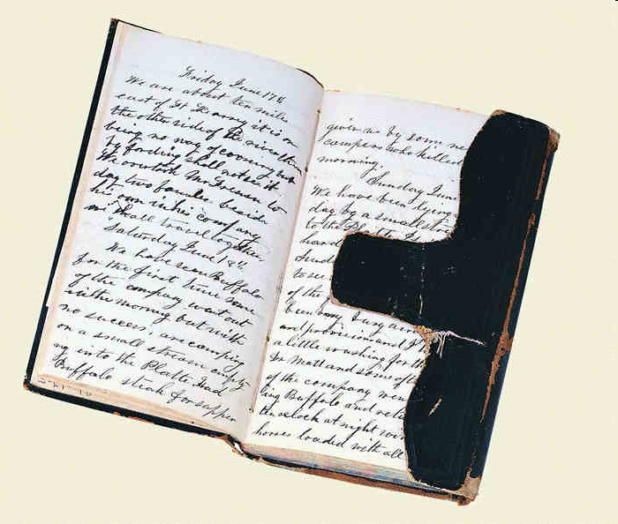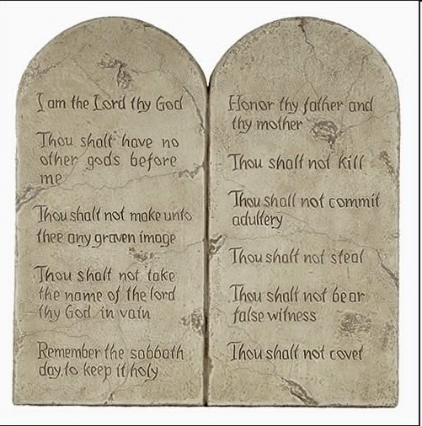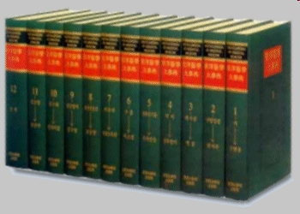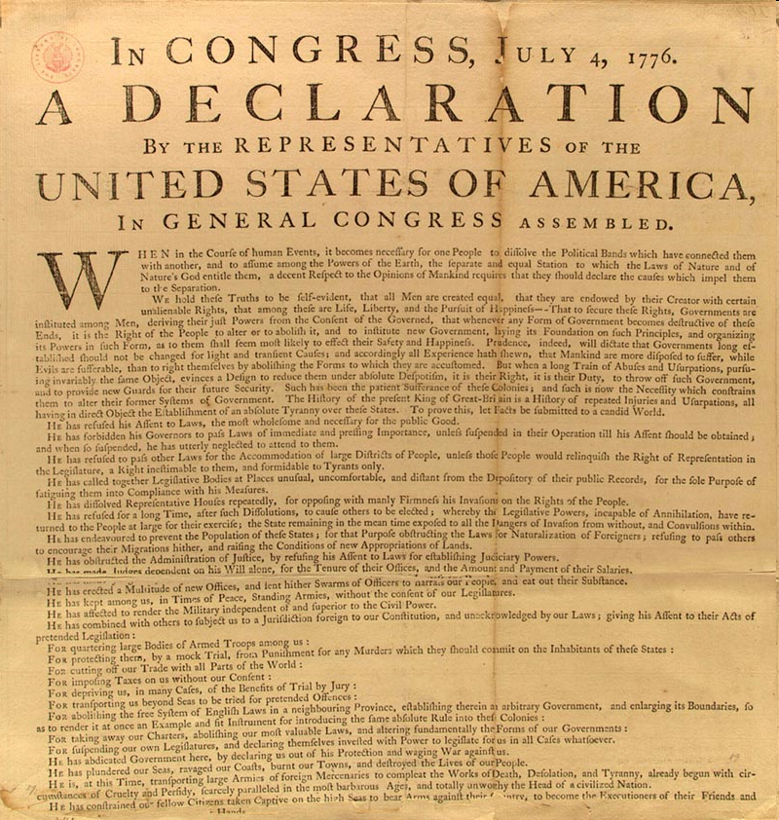

____________ _________________ _________________ _________________ ______________
B.C. and A.D.
Historians have split our calendar into two time periods:
- ______________________________ = “Before Christ,” or “Before Common Era”
- A.D./C.E. – “Anno Domini ” (Latin for “in the year of our Lord”), or “________________________”
We currently live in the year _____________________________.

