NB # _____
Ancient Egypt
Quick Review!
The first civilizations began in the river valleys of Africa and Asia. The river valley civilizations are:
- ________________________________________________
- ________________________________________________
- ________________________________________________
- ________________________________________________
The world’s first civilization, ___________, developed in the Fertile Crescent. However, Sumer would soon be invaded by many other empires including: the Akkadians, Babylonians, Hittites, Assyrians, Persians, and Phoenicians.
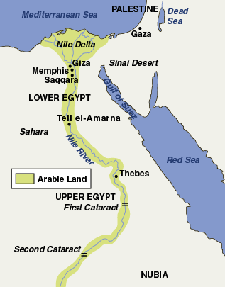
Kingdom of the Nile
The Egyptian civilization was built on the banks of the Nile River in Africa.
- “Black Land” ~ _________________________________________________
- “______________________” ~ desert that stretches across Northern Africa.
Egypt was divided into two regions
- Upper Egypt ~ stretched from the Nile’s first ___________________ (waterfall).
- ____________________ ~ along the__________ (rich land at the mouth of the river) where the Nile empties into the Mediterranean Sea.
Kingdoms of Egypt
Old Kingdom (2575 B.C. - 2130 B.C.)
Pharaohs organized __________________________________________ with a bureaucracy and viziers.
- _______________________________ ~ government with many different jobs and levels (like our government)
- Vizier ~ helped the pharaoh by supervising the government.
During the Old Kingdom, the Egyptians built the _______________________________________ to honor the pharaohs.
Middle Kingdom (1938 B.C. – 1630 B.C.)
A time of trouble with many ____________________ and _____________________________ (dishonest) leaders.
At the end of the Middle Kingdom, foreign invaders called _________________________ took over Egypt.
New Kingdom (1539 B.C. – 1075 B.C.)
Powerful and ambitious pharaohs created a strong and large empire.
- Hatshepsut ~ the ______________________________________ who expanded trade and helped Egypt prosper.
- _____________________________ ~ a great military leader and expanded Egypt’s borders to their greatest extent ever!
- Ramses II ~ ruled for 66 years and successfully ______________________________________________ around Egypt including Syria and Nubia.
Decline of Egypt
After 1100 B.C., Egypt was invaded and conquered by the __________________________ and ____________________.
- In 332 B.C., the last Egyptian dynasty ended when Greeks took control. Later, Roman armies would replace the Greeks.
Egyptian Religion
Like most early civilizations, the Ancient Egyptians were polytheistic, believing in many gods.
- The chief god was Amon-Re ~ ___________________________________________.
- The Pharaohs, who were viewed as ___________________________, received their right to rule from Amon-Re.
Egyptians also believed in the _______________________________, or life after death.
- Each soul had to pass a test to win eternal life – your heart would be weighed against the feather of truth.
- The ________________________________________ helped Egyptians survive the dangerous journey into the underworld providing spells, charms, and formulas.
Afterlife and Mummification
In addition, Egyptians buried their dead with everything they would need for eternity. They used ________________________________ to preserve dead bodies by embalming them.
- Pharaohs were buried in the ___________________________________ with elaborate tombs like 18 year old pharaoh King Tut!
Life in Egypt
Like Mesopotamia, Egypt also used a ________________________________________.
- The ____________________________and ruling family was at the top of society.
- Below the pharaoh were the ___________________________ and priests. Followed by the merchants, scribes, and artisans.
- Most people were peasant __________________ and _____________________ with a terrible life.
Egyptian women had a _______________________________ and greater independence than other ancient civilizations.
- They could do almost everything that men could do!
Egyptian Accomplishments
Ancient Egyptians developed a system of writing called _______________________________.
- Hieroglyphics ~ used _____________________________________________ to represent objects, or sounds.
- In the early 1800s, Jean Champollion found the __________________________________, which helped us ________________________ (or figure out) what each hieroglyph meant.
Egyptians also learned to make a paper-like writing material from _______________________________, a plant that grows along the Nile.
Finally Egyptians contributed to ______________________, astronomy, and _______________________________.

